Accessible PowerPoint Presentations: Key Points

**This is an abridged version of the Accessible PowerPoint Presentations page from the Stanford University Office of Digital Accessibility

Slide Layout and Managing Reading Order: Slides should be arranged so that a screen reader can read the content in the correct order. You can achieve this by using preset slide layouts, which will automatically control the reading order and structure of content placed on the slide.

However, if text boxes are separately created from the preset slide layouts, a screen reader may not read the content in the correct order. If content is manually placed onto a blank slide, you will need to assess and manage the reading order using the Arrange button. (I.e., you may have to manually assign what is read first, second, third, etc.)

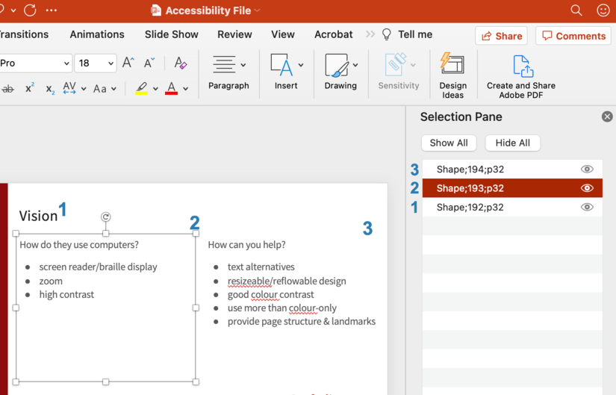

Images
Images that support the content require a text description (also called "alternate text") to communicate the purpose and/or content of the image. Image descriptions should be short and communicate the main purpose of the image. If a longer description of the image is necessary to fully explain its content, consider alternate strategies outlined on the Images concept page.

Image description guidelines
- A text description should convey the purpose or content of the image in approximately 120 characters or less. Avoid repeating the same information as contained in the surrounding text.
- For images that are decorative not relevant to the content, use the check box Mark as decorative.
- If the image is complex, consider providing additional information in the surrounding text of the document while providing a shortened text description.
- Do not include the file format in the alt text (Example: .JPEG, .PNG).
- Do not include “picture of” or “image of” in the alt text.
- For older versions of PowerPoint, leave the Title field blank, and only use the Description field for alt text.

Hyperlinks
- Documents containing hyperlinks to websites or other online resources can be improved by including hyperlink text that is understood by the reader. For instance, using the full hyperlink URL may not make sense to the reader without some context.
- If the PowerPoint presentation is intended to also serve as a handout with resource hyperlinks, content authors may want to create a reference slide at the end that lists the full URL of the hyperlink.

Tables
- When possible, use a simple table structure for tabular data. Using tables with split cells, merged cells, or nested tables can lead to issues with assistive technologies recognizing the appropriate column and row header information in a data table.
- Avoid using a table to manage layout. Instead, use a Slide Layout that orients content into the appropriate visual layout you desire.
- Tables should include the following:
  - At least one header (the row and/or column).
  - Alt Text description summarizing the table.

Color
- Color can be an effective way to communicate ideas and draw attention to information. Insufficient color and contrast can limit the ability of others to perceive and understand the presentation.
- PowerPoint offers a variety of slide themes, but not all of these will provide sufficient contrast. Select Slide Theme Colors with accessible contrast or select Customize Colors to manually select the colors.

Exporting to other formats
Do not use the "Print" to PDF option. This will create a PDF document that lacks PDF tags with no heading information, no alternative text, and no logical document structure. These types of PDF documents will create barriers when accessing the document with assistive technologies.

Creating a PDF
Using “Save As” on a Mac
Users of PowerPoint for Mac should be cautioned that exporting to PDF will not yield an accessible, tagged PDF document; it must be remediated using Acrobat Pro.

Using “Save As” on a Windows PC
- Select File > Save As.
- Select PDF > More options.
- In the Save As dialog, select Options.
- Verify in the Options dialog that Document structure tags for accessibility is selected. Select OK.

Creating a PDF with Acrobat
- Use the Acrobat plug-in in the ribbon. Select the Acrobat tab.
- Select Create PDF.

