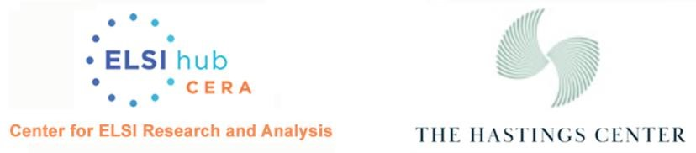

Resources for Law Enforcement and Genetic Data

- “Law Enforcement and Genetic Data” by James Hazel and Ellen Wright Clayton, The Hastings Center Bioethics Briefings
- ELSI Friday Forum on Migrant DNA: Context, Ethics and Legal Issues
- Identity inference of genomic data using long-range familial searches (Science, 9 Nov 2018, Vol 362, Issue 6415, pp. 690-694. DOI: 10.1126/science.aau4832
- A World of Difference? Law Enforcement, Genetic Data, and the Fourth Amendment; Christopher Slobogin and J. W. Hazel. 2021
- Secondary Data Usage in Direct-to-Consumer Genetic Testing: To What Extent Are Customers Aware and Concerned? Public Health Genomics. 2021;24(3-4):199-206. doi: 10.1159/000512660. Epub 2021 Feb 26.

